 | THE HELLENIC LINK, Inc.  ΕΛΛΗΝΙΚΟΣ ΣΥΝΔΕΣΜΟΣ  Member Update- BULLETIN  Editorial Committee: Ahilleas Adamantiades, Evangelia Georgoulea,  Maria-Eleftheria Giatrakou, Dean C. Lomis, Katherine Efthymiatou-Stabile  Andrew Papay, Contributing Editor: Dimitrios Oreopoulos  Acting Editor: Constantine Efthymiou  No. 74, December 2008

CHRISTMAS 2008—NEW YEAR 2009

This Bulletin, “amid the global confusion and crisis of our time,” and the experience of “heavy levels of anxiety due to many ordeals,” with joy and hope refers its readers to the Christmas Encyclicals of the Leaders of our Holy Orthodox Church: the Free- but-Besieged in Constantinople His Holiness Ecumenical Patriarch Bartholomew, and the Caring Arch-Pastor of the Church in America His Eminence Demetrios. The texts of their guiding Messages, reiterating eternal truths applied to current realities, can and should be read with “sober attention” in the following Links:
http://www.goarch.org/news/patriarchalencyclical-2008-12-16-en , and
http://www.goarch.org/news/%20adchristmasencyclical-2008-12-19 , respectively.

In the festive rhythm of the Yuletide, the editors of the Bulletin are privileged to extend Greetings to members and friends alike in the form of the following messages, addressed to us by Hellenic Link members; we wish to share the selected messages with all of our members and friends:

A. Vasiliki Tsigas-Fotinis, a Hellene Educator, has sent traditional Hymns and Carols, sung by Greeks during Christmas and on New Year’s Day. The materials received represent and indeed express fountain-head attributes of our being and of our long standing heritage as Hellenes. As cultural specimens originating in various historical eras and diverse geographical cradles of Hellenism, they offer precious documentation and didactic elements for a truly “Environmental Education” (for the meaning, see A Hellenic Education Plan for America, NY 2005, Unit IV), and an enlightened projection to and imparting in the young of a justified sense of continuity and unity of Hellenism.
From Vasiliki’ s rich repertory of cultural resource documents, utilized in her well-reasoned and edifying teaching-- kindly shared with us on this celebratory occasion, the available space allows inclusion of only two Christmas and one New Year’s Carols and one New Year’s song. The latter may be sung and enjoyed by the entire family gathered around Vasilopita on St. Basil’s Day.

Christmas Carols

Βυζαντινὰ Κάλαντα Χριστουγέννων
(Σιναΐτικη ἀλφαβητικὴ ἀκροστοιχίδα)
Ἦχος α´. Ῥυθμὸς τετράσημος.

Ἄναρχος Θεὸς καταβέβηκεν καὶ ἐν τῇ Παρθένῳ κατώκοισεν
ερου ρεμ ερου ρεμ ρερου ρερου ρερου ρεμ
χαῖρε Ἄχραντε.
Βασιλεὺς τῶν ὅλων καὶ Κύριος ἦλθε τὸν Ἀδὰμ ἀναπλάσασθαι
ερου ρεμ ερου ρεμ ρερου ρε και τενενά
Δέσποινα.
Γηγενεῖς σκιρτάτε καὶ χαίρεσθε, τάξεις τῶν ἀγγέλων εὐφραίνεσθε
ερου ρεμ ερου ρεμ ρερου ρερου ρερου ρεμ
χαῖρε Ἄχραντε.
Δεῦτε ἐν σπηλαίῳ θεάσασθαι, κείμενον ἐν φάτνῃ τὸν Κύριον
ερου ρεμ ερου ρεμ ρερου ρε και τενενα
χαῖρε Δέσποινα.
Ἐξ ἀνατολῶν μάγοι ἔρχονται δῶρα προσκομίζουσι ἄξια.
ερου ρεμ ερου ρεμ ρερου ρερου ρερου ρεμ
χαῖρε Ἄχραντε.
Ζητοῦν προσκυνήσαι τὸν Κύριον, τὸν ἐν τῷ σπηλαίῳ τικτόμενον.
ερου ρεμ ερου ρεμ ρερου ρε τε και τενενα
χαῖρε Δέσποινα.
Ἡ ἀστὴρ τοὺς μάγους ὁδήγησεν ἄνω τοῦ σπηλαίου τοὺς ἔφερεν.
ερου ρεμ ερου ρεμ ρερου ρερου ρερου ρεμ
χαῖρε Ἄχραντε.
Ὑπὸ ἀρχαγγέλων ὑμνούμενον καὶ τῶν Σεραφεὶμ δοξαζόμενον.
ερου ρεμ ερου ρεμ ρερου ρε τε και τενενα
χαῖρε Δέσποινα.

Φῶς ἐν τῷ σπηλαίῳ ἐπέφανεν καὶ τὸν κόσμον ὅλον ἐφώτισε.
Ἅγιος, Ἅγιος, Ἅγιος ὑπάρχεις καὶ Κύριος.

Χαίρουσα ἡ κτίσις ἀγάλλεται καὶ πανηγυρίζει, εὐφραίνεται.
ερου ρεμ ερου ρεμ ρερου ρερου ρερου ρεμ
χαῖρε Ἄχραντε.

Ψάλλοντες Χριστὸν τὸν Θεὸν ἡμῶν τὸν ἐν τῷ σπηλαίῳ τικτόμενον.
Ἅγιος, Ἅγιος, Ἅγιος ὑπάρχεις καὶ Κύριος.

Ὢ παρθενομήτορ καὶ Δέσποινα· σῷζε τοὺς εἰς Σὲ καταφεύγοντας.
ερου ρεμ ερου ρεμ ρερου ρερου ρερου ρεμ
χαῖρε Ἄχραντε

Κάλαντα Χριστουγέννων Πελοποννήσου.
Ἦχος α´. Ῥυθμὸς τετράσημος.
Χριστούγεννα πρωτούγεννα, πρώτη γιορτὴ τοῦ χρόνου,
γιὰ ἐβγᾶτε, δέστε, μάθετε, πὼς ὁ Χριστὸς γεννιέται,
γεννιέται κι’ ἀναθρέφεται στὸ μέλι καὶ στὸ γάλα,
τὸ μέλι τρῶν’ οἱ ἄρχοντες, τὸ γάλα οἱ ἀφεντάδες
καὶ τὸ μελισσοχόρταρο τὸ λούζουντ’ οἱ κυράδες.
Κυρὰ ψιλή, κυρὰ λιγνή, κυρὰ γαϊτανοφρύδα,
κυρὰ μ’ ὅταν στολίζεσαι νὰ πᾷς στὴν ἐκκλησιά σου,
βάζεις τὸν ἥλιο πρόσωπο καὶ τὸ φεγγάρι ἀγκάλι
καὶ τὸν καθάριο αὐγερινὸ τὸν βάζεις δαχτυλίδι.
Ἐμεῖς ἐδῶ δὲν ἤρθαμε νὰ φᾶμε καὶ νὰ πιοῦμε,
μόνο σᾶς ἀγαπούσαμε κι’ ἤρθαμε νὰ σᾶς δοῦμε·
ἐδῶ ποὺ τραγουδήσαμε πέτρα νὰ μὴ ραγίσει
κι ὁ νοικοκύρης τοῦ σπιτιοῦ πολλοὺς χρόνους νὰ ζήσῃ.
Δῶστε μας καὶ τὸν κόκορα, δῶστε μας καὶ τὴν κότα,
δῶστε μας καὶ πέντ’ ἕξ’ αὐγά, νὰ πᾶμε σ’ ἄλλη πόρτα

Πρωτοχρονιάτικα κάλαντα
Εις αυτό το νέο έτος βασιλείου εορτή,
Ήρθα να σας χαιρετήσω με την πρέπουσα ευχή!
Βοηθός σας να σας γίνει ο πανάγαθος θεός,
Και προστάτης και φυλλάτης εις εσάς παντοτινός!
Εις τα τέκνα σας να δίνει τη δεούσαν προκοπήν,
Μάθησην και σωφροσύνην και τρισόλβιον ζωήν!
Με το καλό να τους ιδείτε τους ταξιδεμένους σας
Με το καλό να τους ιδείτε τους ξενιτεμένους σας!

Εις αυτό το νέο έτος
Βασιλείου εορτής
ήρθα να σας χαιρετήσω
με την πρέπουσα ευχή
όσους έχετε στα ξένα
να τον δείτε με χαρά
με υγεία και ευτυχία
τον θεό παρακαλώ
Αυτό το σπίτι που ρθαμε πέτρα να μην ραγήσει και ο νοικοκυρης του σπιτιού πολλά χρόνια να ζήσει!

THE HELLENIC LINK, Inc.

A NON PROFIT CULTURAL AND SCIENTIFIC ASSOCIATION

OF HELLENES AND PHILHELLENES

INCORPORATED IN DELAWARE

Suite No. 278, 38-11 Ditmars Blvd, Astoria, New York 11105
Web Site: http://www.helleniclink.org Email: info@helleniclink.org
Contact Telephone : (718) 217- 4285 .

Πάει ο παλιός ο χρόνος....

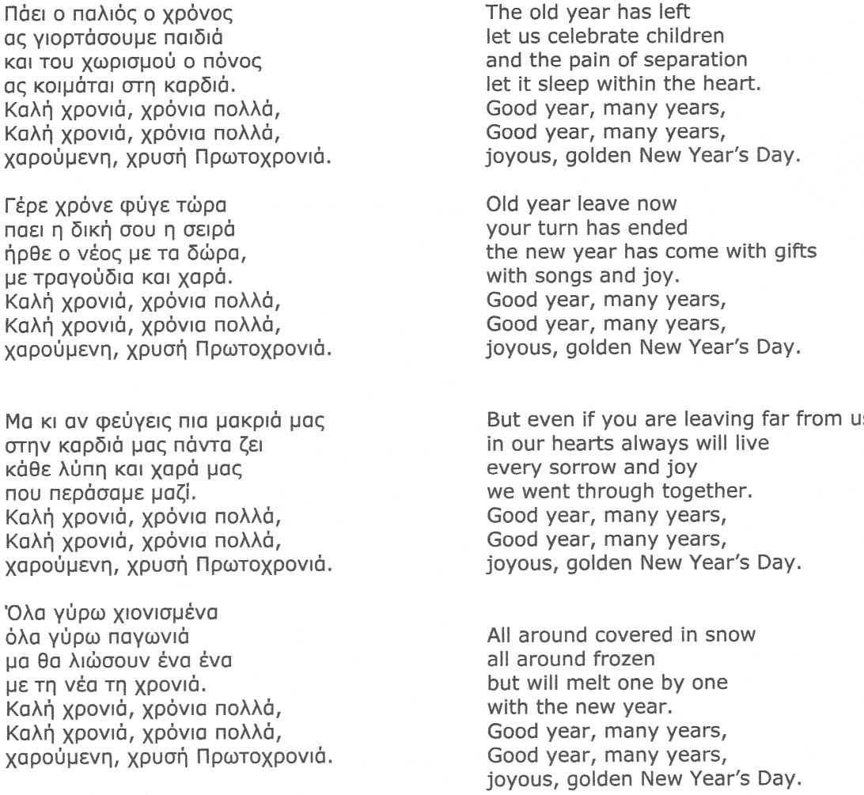

Vasiliki Tsigas-Fotinis, Ed. D. is with the Faculty of Caldwell College, NJ; she has been an Educational Consultant and High School Curriculum Coordinator for the Department of Religious Education of the Greek Orthodox Archdiocese of America.

Β. ας γιορτάσουμε παιδιάFrom the remote and frigid Manitoba, Canada, Pandelis Halamandaris is sending us the heart-warming tidings of Christmas with his Greeting Card depicting it with bells, obviously pealing and relaying the original message of the angels in Bethlehem: “Glory to God in the highest and on earth peace, good will among all people.” What a “joyful and triumphant” message! Full of soothing compassion! It is calling again the humanity today to be freed from the shackles of its own making!

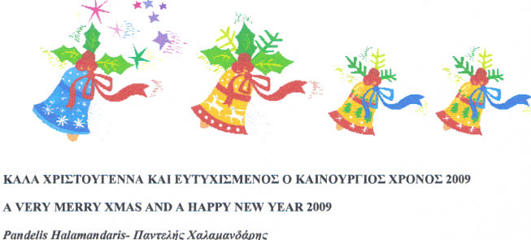

Pandelis Halamandaris, Ph.D., Ed.D is Professor Emeritus of Education, Brandon University, Deputy Director, Centre for Hellenic Civilization, University of Manitoba, Winnipeg.

C. As the irreversible time of departure of the old year 2008 is approaching fast and the dawn of a New Year -- at the moment still inscrutable and unfathomable -- is drawing near, our friend and co-worker Dimitrios Oreopoulos, also from Canada, wishes to remind us of the great value of correctly assessing the fleeting moment of the NOW time, when we have a short opportunity to act and influence the course and outcome of important personal-life events favorably for ourselves. The reminder is depicted in the form of a series of audio-visual slides under the title: “There are 4 things you cannot retrieve.” The featured “story” itself might involve in every day life any of us, who, subsequently, would probably dismiss it as unfortunate, but trivial. The message of this slide show written in Greek is far more profound and worthy of attention, however; it is subtle and meaningful, as is gracefully developed. [To view it, click on 4_Things_gr appearing as attachment to this e-mailed Bulletin. If the Bulletin you received is printed, you can view the show by visiting the Web Site of The Hellenic Link, Inc. http://www.helleniclink.org Just click on the above title-heading in the entry of Bulletin No. 74.]

Dimitrios Oreopoulos, MD, Ph.D., FRCPC, FACP, is Professor of Medicine, Toronto
Western Hospital.

Our Responsive Greeting

We are grateful to our three colleagues for the nature as well as the ethical dimension of their festive messages, offered in the best tradition of the 12-Day-Period Greek Orthodox Celebration. We should all perceive these messages in the way they are naturally and plainly perceived by children; they are the most avid among us in their keen anticipation of all celebrated events of the Season, from Nativity to Epiphany. It is their innocence, purity and simplicity that explain and seal their experience (βίωμα). We grownups, hardened by the experiences in life, may have difficulty in accepting and living such biomata. But the juvenile representatives of humanity, for what and how they are find themselves in the best of terms and harmony with eternity. Accordingly, we should restore their qualities of soul in our inner-being to be able to reconcile ourselves with our Creator, our fellow human beings, and, none the least, our problem-ridden ego. The restoration of this peace, we believe, was the ultimate wish of the Greetings we received from our beloved friends and esteemed colleagues.
In reciprocating, we are extending our sincere thanks to them and our warmest wishes to all:

For a most Joyous Christmas and a Healthy, Creative, and Prosperous in-Peace New Year!

At Your Service,

The Editorial Committee of the Hellenic Link Bulletin

Professionals and students in every discipline or field of endeavor, whether of Greek Descent or Philhellenes, are cordially invited to join the Hellenic Link, Inc. as members. It is quite easy and useful! Just contact us at our street/e-mail address or telephone (page 4).

